SOLUTION



ARCHITECTURE

*Containment Zone Alert Application*

Akash L

Barath Kannan K

Maheswaran C

Monishadhith K T

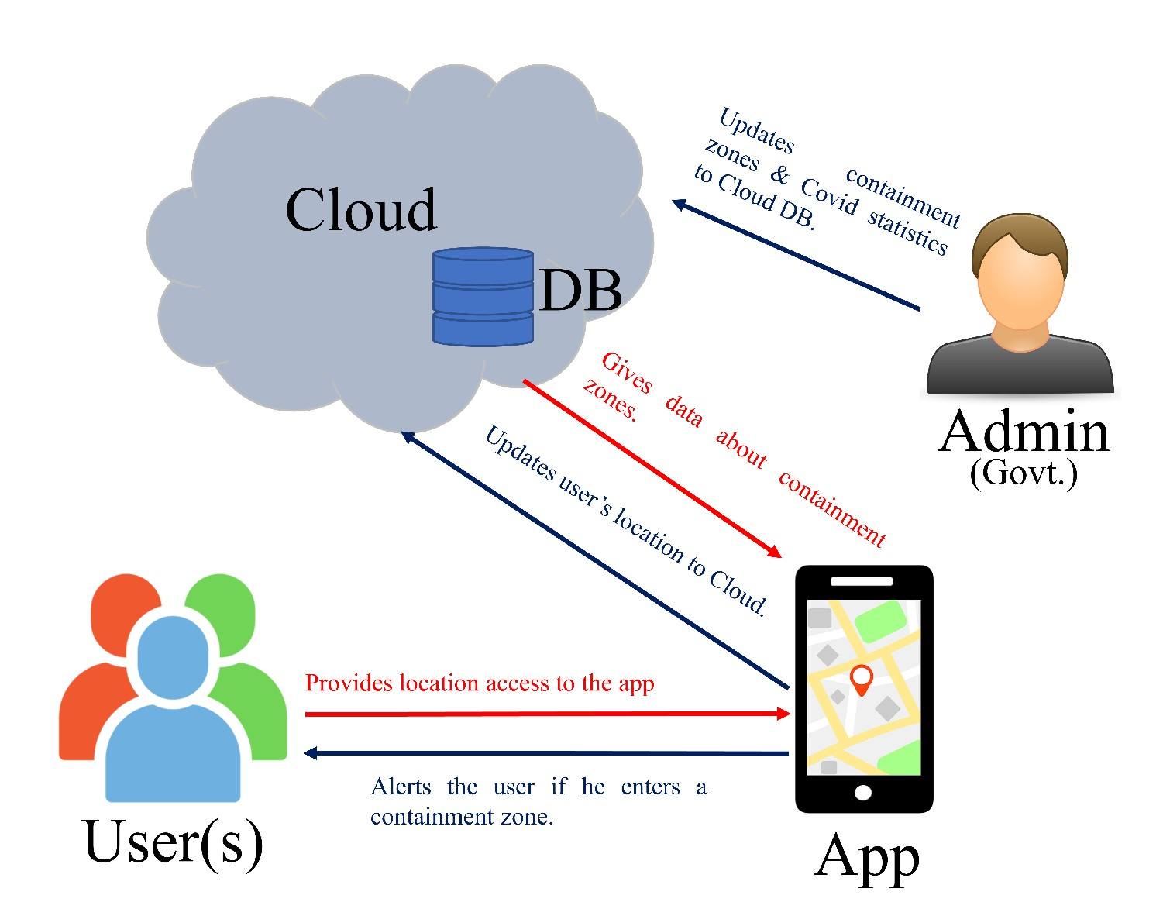

CONTAINMENT ZONE ALERTING APPLICATION

Solution Architecture

|  |  |
| --- | --- |
| **Date** | 04 October 2022 |
| **Team ID** | PNT2022TMID12468 |
| **Project Name** | Project - Containment Zone Alerting Application |
| **Maximum Marks** | 4 Marks |

Containment Zone Alert Application – Solution Architecture Block Diagram

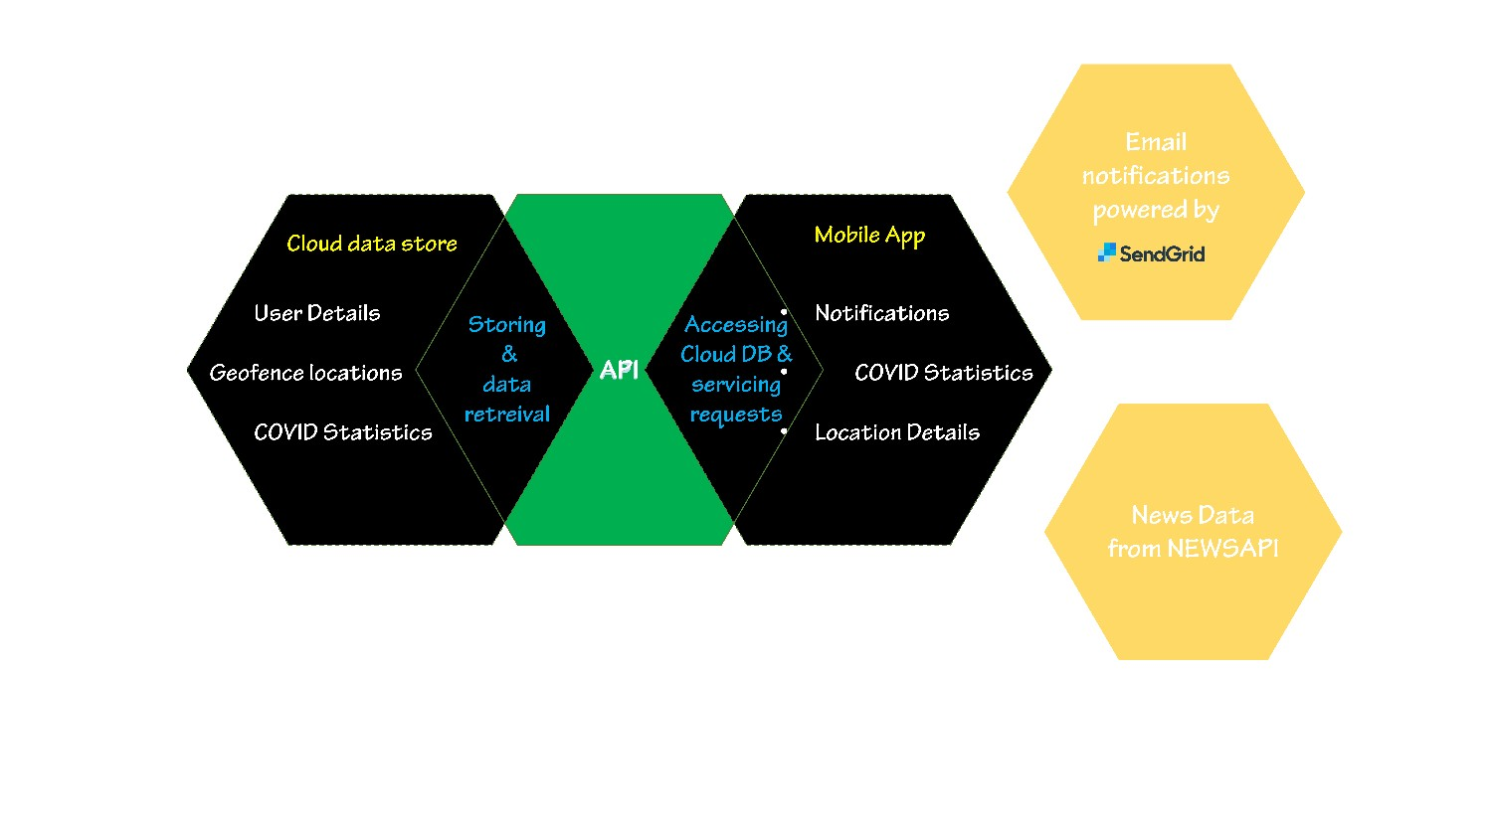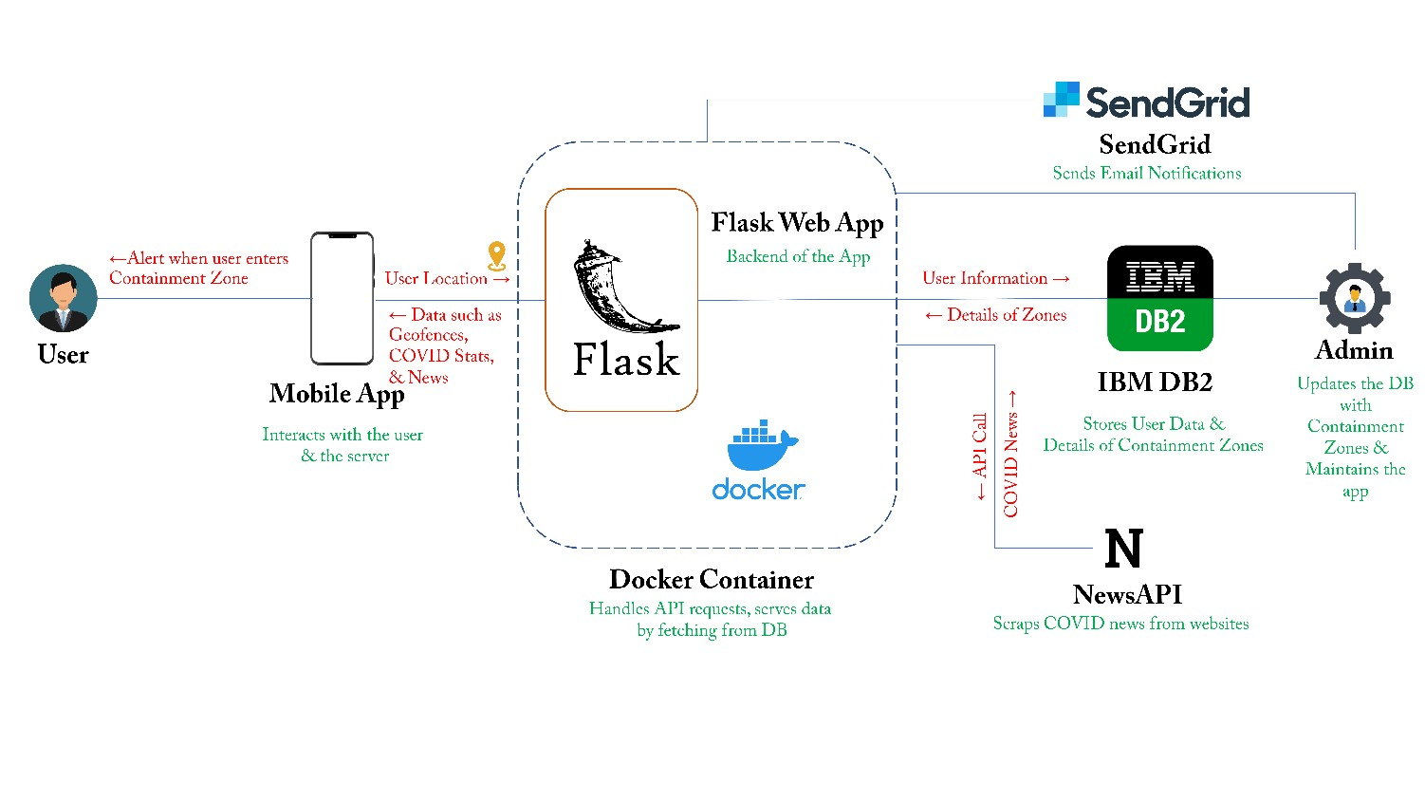

Modules

Technical Architecture